**About Page**

Why JoyeGroup?

Solid Foundation and Experience

Founder and President

Chris Joye



* *Joye’s Information Technology career has spanned for more than 38 years*
* *He has been a software developer, designer, project manager and IT executive*
* *Worked in Banking, Manufacturing, Insurance, Health Care, Mortgage Lending, and other industries*
* *Successfully lead organizations to improved information technology investments and return*
* *Successful Chief Information Officer (CIO) experience*
  + *Mentored, managed and led hundreds of people with information engineering solutions*
* *CEO Experience: Chairman of the Board of Commissioners (Trustees) of the 5th largest SC college ($84 million budget)*
* *Cyber Security Expert*
* *Owned and managed several successful and profitable IT companies*
* *Successfully led large major projects for over 25 years.*
  + *Successes:*
    - *IT manager for the new Ingersoll-Rand (IR) Worldwide Strategic Sourcing Division and implemented a Data Warehouse that assisted in saving IR $100 million the first year.*
    - *Project manager and successfully implement SAP (ERP) for the State of SC. Saved Government over $25M annually by consolidating legacy information systems.*

Education: Graduate – Clemson University – BS Industrial Management

Area of Concentration: Computer Science

Graduate – UNC Greensboro – MBA (Highest Honors)

Certifications – Security+

Professional Manager of Projects (PMP)

Certified Internet Webmaster (CIW)

Remove this from About Page??

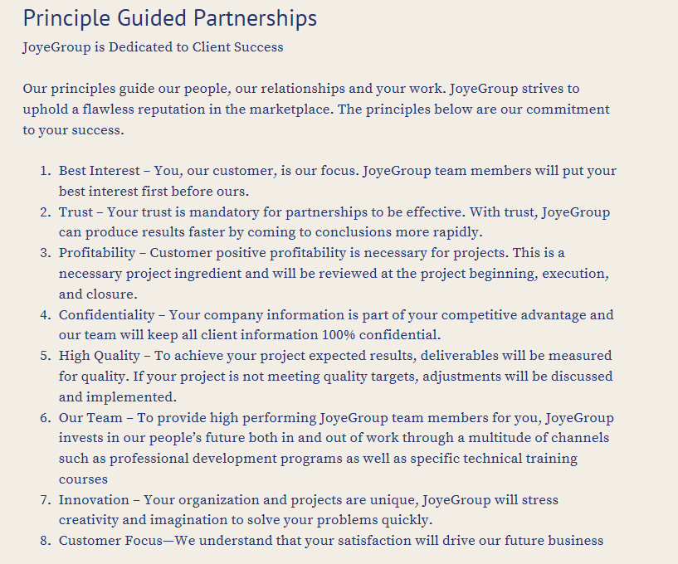

**Cyber Security Page**

Recent Successful Cyber Security Work

**Customer Challenge:** Consolidation of multiple Internet facing devices into a single unified threat management (UTM) appliance which will support NAT, remote access, and site to site VPN capability.

**JoyeGroup Actions**: Assisted client in procuring UTM hardware (appliances) and configured and deployed them at multiple client locations.

**Customer Benefit:** The modern perimeter protection greatly improved their security posture which will reduce the risk of business loss due to malicious software or cyberattack.

*Your Action: Allow JoyeGroup Cyber Security Experts to perform an assessment of your cyber security posture. We will provide a written report of suggestions and meet with you to discuss the suggestions in detail. Our Cyber Security Experts can also assist you in your cyber security remediation work to provide a strong security posture.*

**Subject Matter Experts Page**

Recent Successful Work

**Customer Challenge 1:** A client has a massive data conversion for a new system implementation.

**JoyeGroup Actions**: Provided talent to assist with data conversion requirements, design, development, and implementation.

**Customer Benefit:** New systems will to improve worker efficiencies. If the system’s converted data is incomplete, wrong or unacceptable, the new systems will not provide needed benefits to improve profits.

**Customer Challenge 2:** A client needed a better communication platform to keep employees informed and Executives aware of work and project(s) progress.

**JoyeGroup Actions**: Implemented SharePoint and Project Server.

**Customer Benefit:** SharePoint is a collaborative tool and this tool has greatly improved communication and provided Executives information faster and more accurate to make better decisions. Project Server will assist project managers to manage all company resources and provide Executives a view of all projects. This view is of resources, costs, and timelines.

*Your Action: Request a free consultantion for our JoyeGroup team to work with you to review your information technology investment and determine how to better spend your IT dollars to improve your profits.*